Minimization of DFA

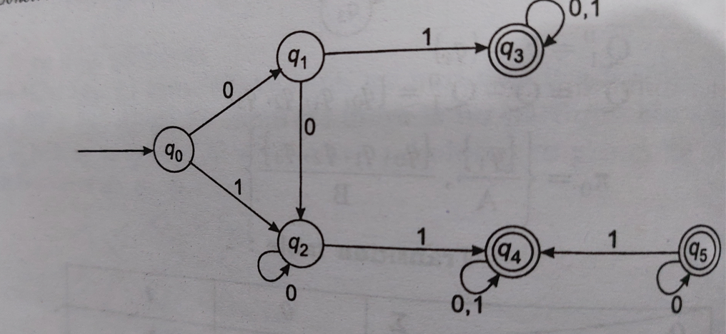

Solution:

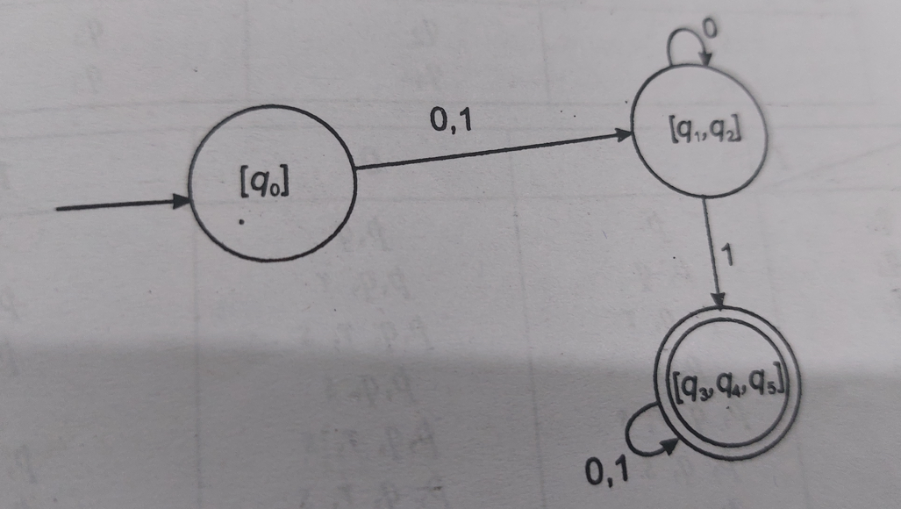

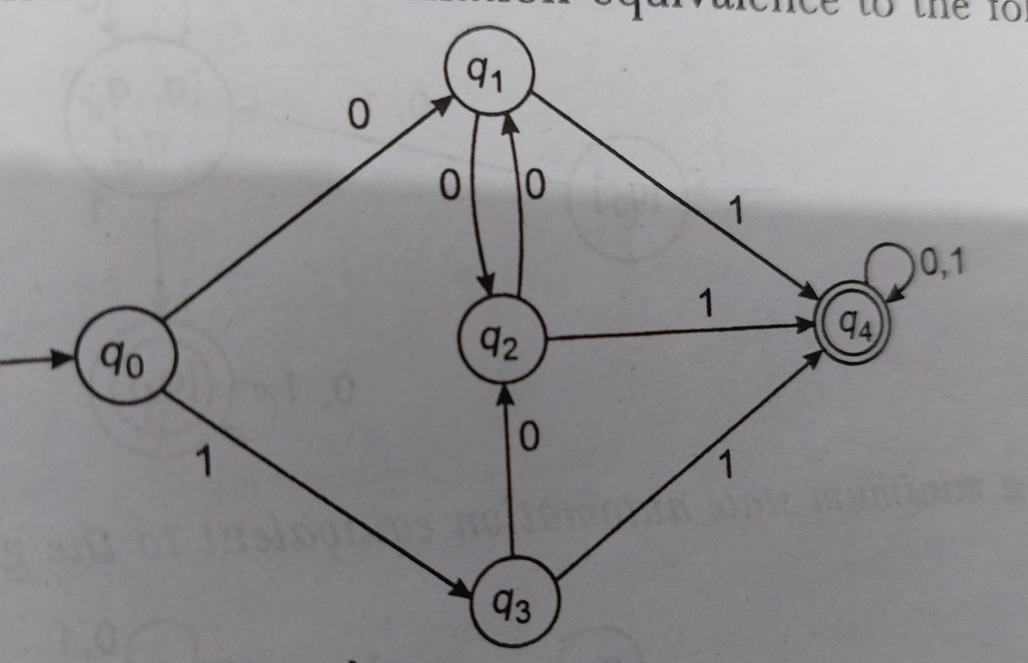

Solution

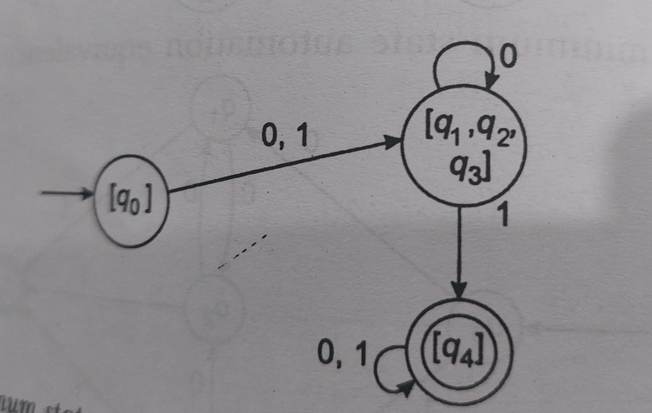

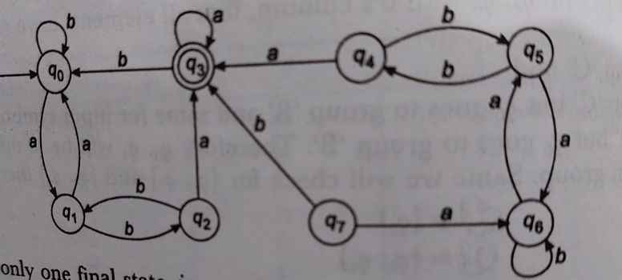

Solution

By default state q4 ,q5,q6,q7,q8 will be remove.

**Mealy and Moore Machine**

1. Design a Moore machine that will read sequence made up of letters a,e,I,o,u and will give as output same character except when an ‘I’ is followed by ‘e’ ,it will be changed to ‘u’ .Also design Mealy machine for the above problem.

Solution

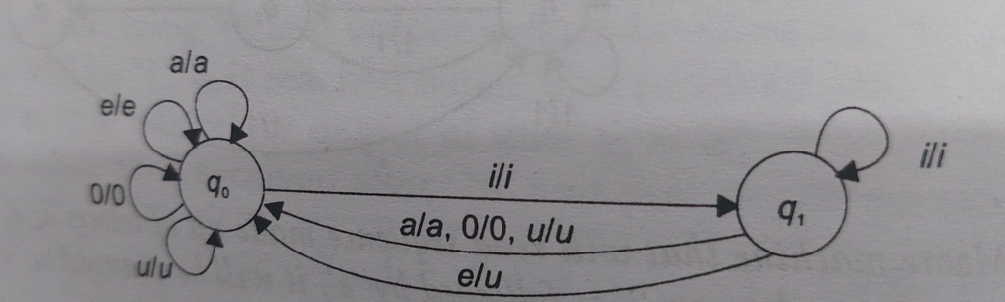

Moore machine

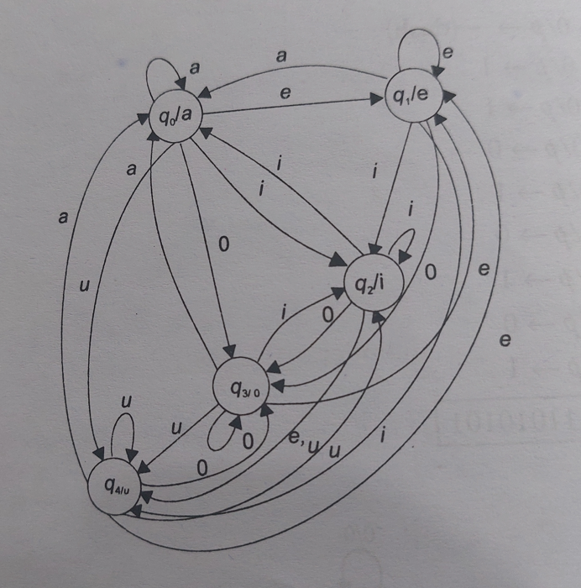

1. Design a Moore machine that gives an output ‘1’ if input of binary sequence a ‘1’ is preceded by exactly two zeros.

Solution

Moore Machine

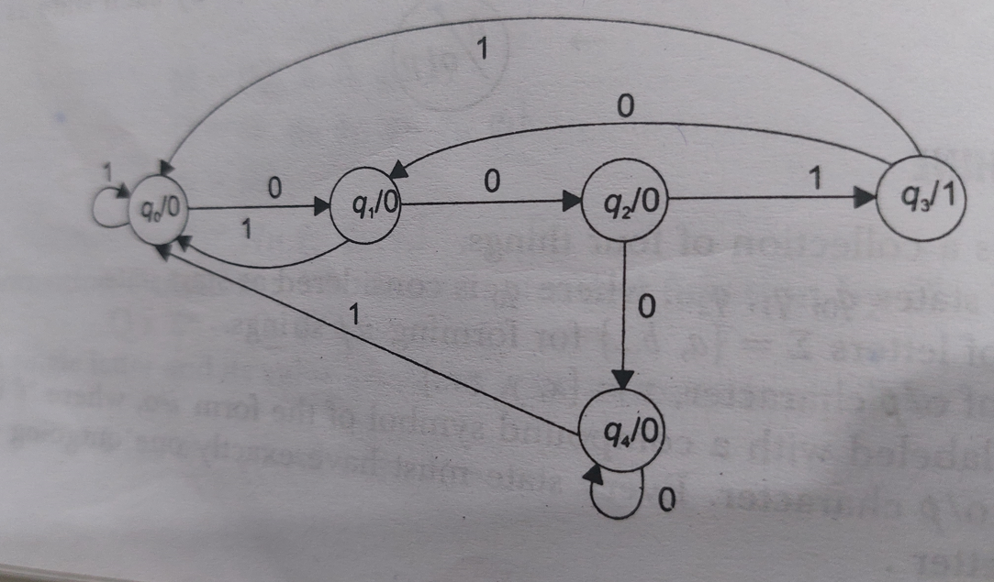

1. Consider a Moore machine, construct a Mealy machine equivalent to this Mealy machine.

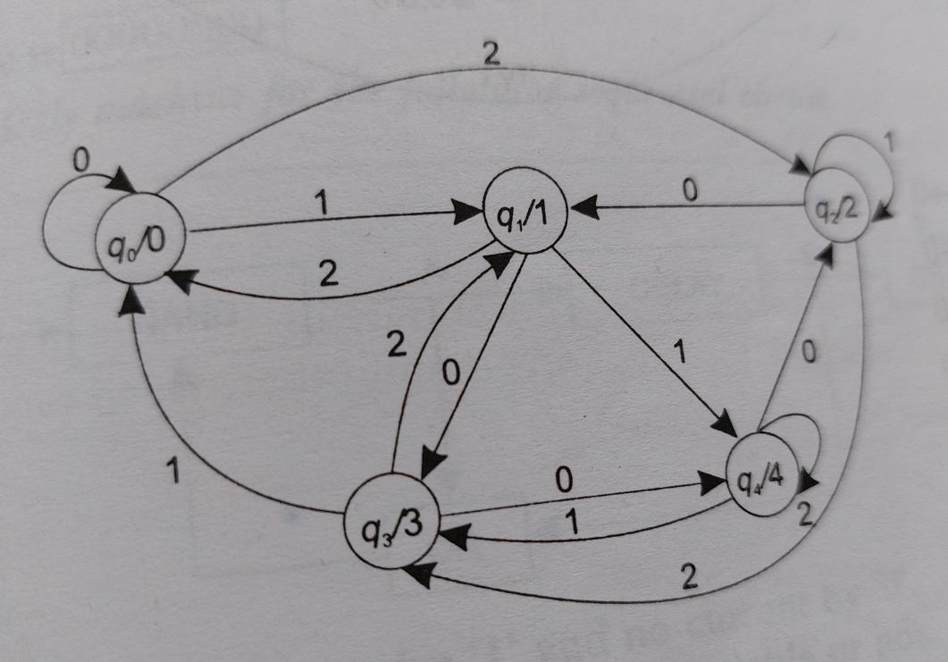

Solution

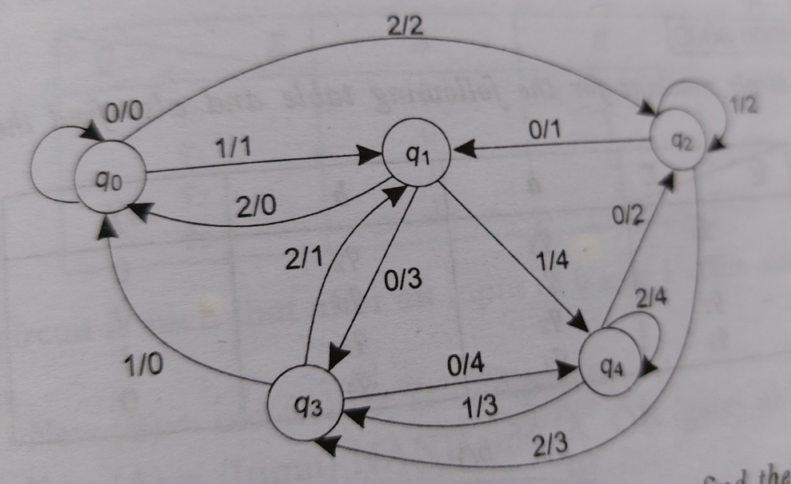

1. Consider a Mealy machine, construct a Moore machine equivalent to this Mealy machine.

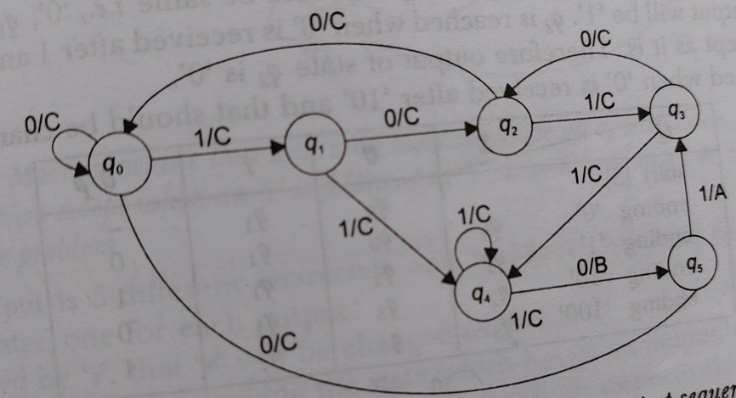

Solution:

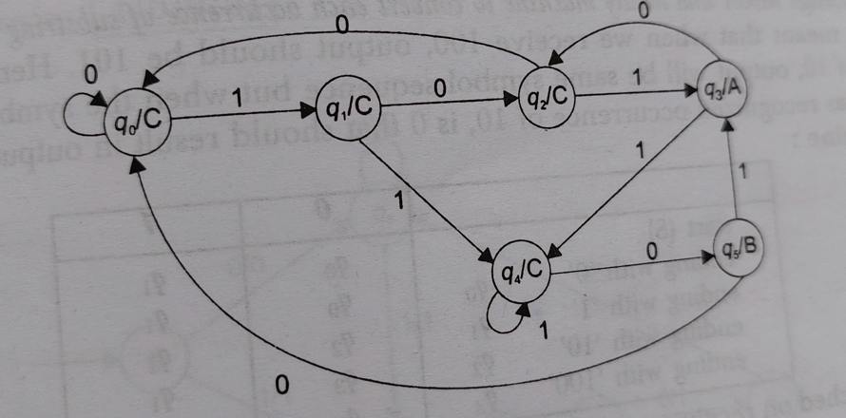

1. Construct Transition table of given Moore machine.



1. Construct Transition table of given Mealy machine.

